**ATATURK UNIVERSITY**



**12TH BRIDGING CULTURES SUMMER SCHOOL PROGRAM**

**24 JUNE – 05 JULY 2019**

|  |  |  |  |  |  |  |
| --- | --- | --- | --- | --- | --- | --- |
| **June 30, Sunday** | **July 1, Monday** | **July 2, Tuesday** | **July 3, Wednesday** | **July 4, Thursday** | **July 5, Friday** | **July 6, Saturday** |
| Free Time | Course:  Save the Earth and Soil  *Prof. Taşkın Öztaş* | Cultural activity:  DAYTAM | International day:  Presenting your  country, culture and  university | Course:Cutting edge  technologies and their  role in near future  *Assoc. Prof. Bülent Çavuşoğlu* | Visit Taşhan Shopping Center and gift shops in  downtown | Departures:  From Erzurum airport  and bus station |
| Free Time | Cultural activity:  Ebru art is a king of picture drawing on water that will be taught | Cultural activity:  Veterinary Hospital/Farm /Greenhouse | International day:  wear your national  dress, bring your  national flag and food | Cultural activity: Cinema or Theatre  excursion in the  campus or in downtown | Free time:  Having a  group of friends to  visit the places you  want | Departures:  From Erzurum airport  and bus station |

Notes: 1. Students will stay in Guesthouse of Ataturk University. They will have breakfast, lunch and dinner at the same place in the days there is no trip to out of town.

2. There may be slightly changes in the program

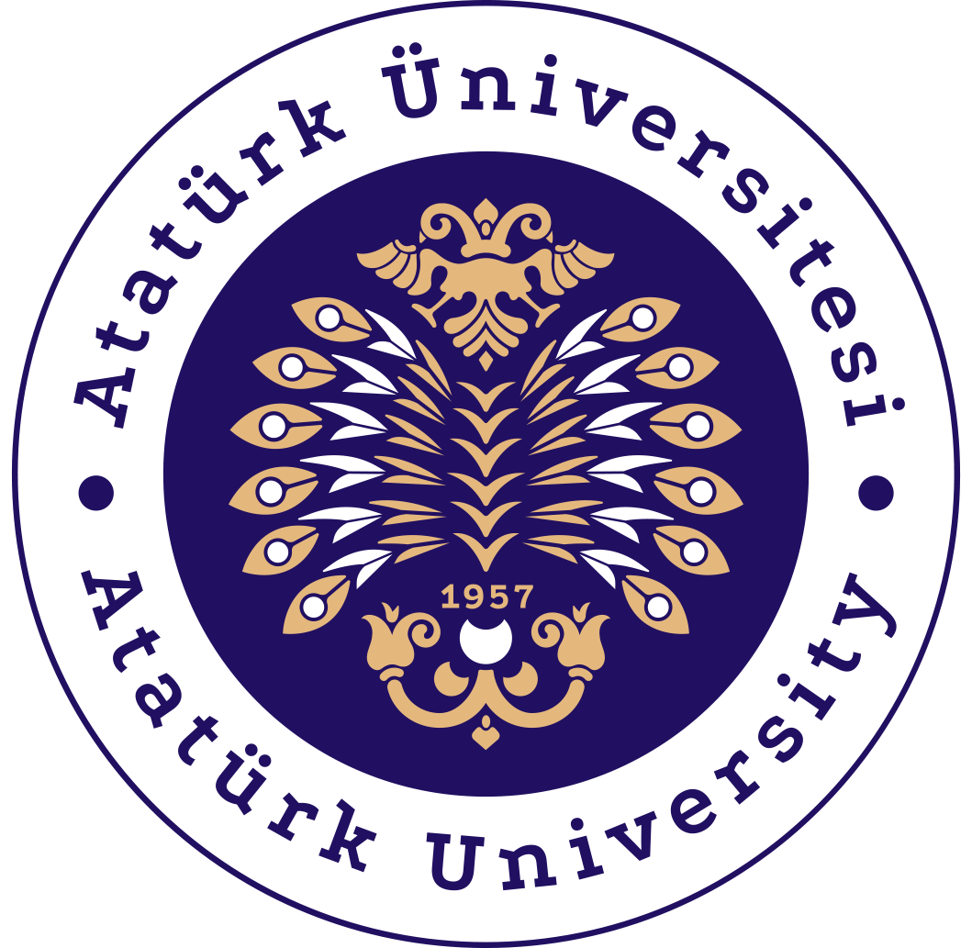

|  |  |  |  |  |  |  |
| --- | --- | --- | --- | --- | --- | --- |
| **June 23, Sunday** | **June 24, Monday** | **June 25, Tuesday** | **June 26, Wednesday** | **June 27, Thursday** | **June 28, Friday** | **June 29, Saturday** |
| Arrivals:  Pickup at Erzurum  airport and bus  station | Visit Office of  International Affairs,  meet the president  and tour campus | Course:  Introduction to  Turkish Language and  simple practices | Course:  Turkish Financial System and BIST  *Asst. Prof. Ensar Ağırman* | Daily Tour I:  VisitTortum  Waterfall and have  lunch (fish) at seven  lakes | Course:  Fish in Human Nutrition  *Prof. Murat Arslan* | Daily Tour II:  Breakfast in  Bayburt and visit  Sumela Monastery in Trabzon |
| Arrivals:  Pickup at Erzurum  airport and bus  station | Course:  Introduction to  Turkish Language and  simple practices | City tour:  Visit some  important historical  and scenery places | Course:  Introduction to  Turkish Language and  simple practices | Visit Narman  Chimneys and return  back to Erzurum | Course:  Spending time in  Bowling Center of  Ataturk University | Lunch in Akcabat, visit  historical places in  Trabzon |